Ideation Phase
Brainstorm & Idea Prioritization Template

Date | 3 October 2026
Team ID | SWTID-2026-5226
Project Name | Import Data using Transform Maps (Spreadsheet)
Maximum Marks | 4 Marks

Brainstorm & Idea Prioritization Template:
Brainstorming provides a free and open environment that encourages everyone within a team to participate in the creative thinking process that leads to problem solving. Prioritizing volume over value, out-of-the-box ideas are welcome and built upon, and all participants are encouraged to collaborate, helping each other develop a rich amount of creative solutions.
Use this template in your own brainstorming sessions so your team can unleash their imagination and start shaping concepts even if you're not sitting in the same room.
Reference: https://www.mural.co/templates/brainstorm-and-idea-prioritization
Step-1: Team Gathering, Collaboration and Select the Problem Statement
Team gathering: the project was planned and shared across five team members, each owning one or more stories inside the SkillWallet workspace (ServiceNow System Administrator program).
Team Member | Stories Owned
Monika R | Creation Of Spreadsheet
Priyanka D | Creation of Tables; Transform Data & Validate
Archana R K | Create Importset Table; Create Transform Map
Nithyasree M | Enable Coalesce to Avoid Duplicate Records
Pushpavalli B | Inserting New Data In Excel Format; Report 1

Problem statement: How might we import employee data from a spreadsheet into ServiceNow so that it is validated, transformed and stored in the target table without creating duplicate records, and then report on it through charts and a dashboard?
The spreadsheet data is uploaded into a ServiceNow Import Set Table, where it is validated and transformed before being inserted or updated in the target table using a Transform Map.
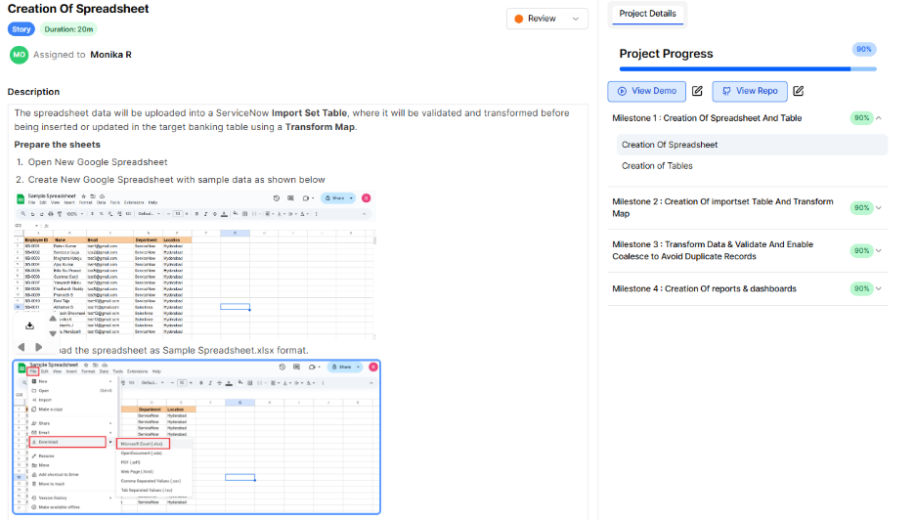
Figure 1: Project workspace showing the four milestones and the first story
Step-2: Brainstorm, Idea Listing and Grouping
Ideas and tasks from the brainstorm were listed and then grouped into four milestones. Each group below is one milestone of the project.
Group (Milestone) | Ideas / Stories (Owner)
Milestone 1: Creation Of Spreadsheet And Table | Prepare a Google Spreadsheet with sample employee data (Employee ID, Name, Email, Department, Location) and download it as .xlsx (Monika R)  Create the Employee Test table and add its fields (Priyanka D)
Milestone 2: Creation Of Importset Table And Transform Map | Create the Import Set Table (Employee Import, u_employee_import) by loading the spreadsheet (Archana R K)  Create the Transform Map (Sample Spreadsheet Import) from Employee Import to Employee Test and auto-map the fields (Archana R K)
Milestone 3: Transform Data & Validate And Enable Coalesce to Avoid Duplicate Records | Run the transform and validate the records in the Employee Test table (Priyanka D)  Enable Coalesce on a key field so repeat imports update records instead of duplicating them (Nithyasree M)  Insert new data in Excel format to test insert versus update behaviour (Pushpavalli B)
Milestone 4: Creation Of Reports & Dashboards | Report 1: Employees by Department, as a pie chart grouped by Department with a count aggregation (Pushpavalli B)  Add the reports to a dashboard (owner not shown in the screenshots)
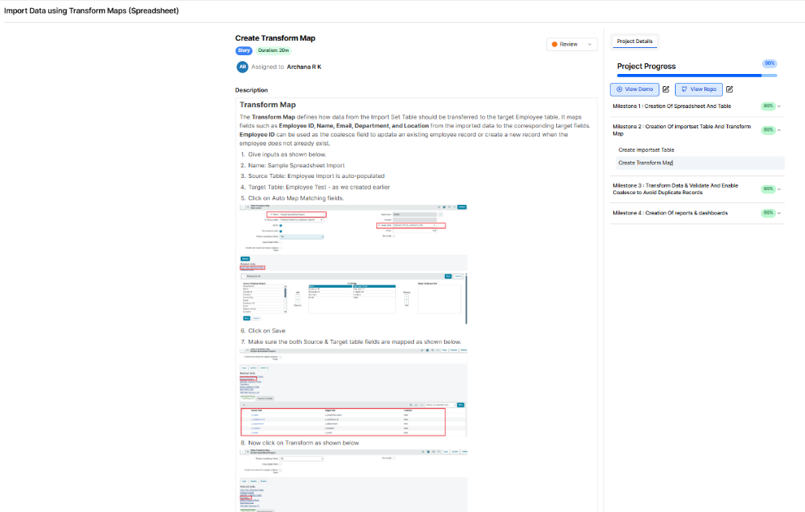
Figure 2: Create Transform Map story (Milestone 2)
Step-3: Idea Prioritization
Ideas were prioritized by how much each one is needed for the data import to work (impact) against the planned time (effort). Durations are the story durations shown in the workspace. The impact ratings and ranking are a suggested order and can be adjusted by the team.
Rank | Idea / Story | Duration | Impact | Reason
1 | Creation Of Spreadsheet | 20m | High | Source data must exist before anything can be imported
2 | Creation of Tables | 20m | High | The target Employee Test table must exist to receive data
3 | Create Importset Table | 20m | High | Staging area where uploaded rows are held and validated
4 | Create Transform Map | 20m | High | Maps source fields to target fields; core of the project
5 | Transform Data & Validate | 3h 20m | High | Confirms the import succeeded and the records are correct
6 | Enable Coalesce to Avoid Duplicate Records | 3h 20m | Medium | Prevents duplicate employees on repeat imports
7 | Inserting New Data In Excel Format | 3h 20m | Medium | Proves coalesce updates existing rows and inserts new ones
8 | Report 1: Employees by Department | 20m | Medium | Gives a first visual summary of the imported data
9 | Adding Reports to Dashboard | Not shown | Low | Presentation layer; can follow once reports exist

